Sprint Backlog:

As a customer, I want to add an item to my order so that I can see a summary of my order later at checkout and buy it.

When adding an item, it will be necessary to provide information about the item (id?), quantity and (optional) extras.

| PB-ID | ID | Task Title | Responsible | Estimate (hours) | Status |
| --- | --- | --- | --- | --- | --- |
| 0 | 1 | Class diagram from the domain model with the Client/Server part with (Model, network, GUI) - EMPHASIZE INTERFACES | Everyone | 32 (8*4) | Completed |
| 0 | 2 | Designing the database (EER, relational schema, GR). | Laura + Daniel | 16 (8*2) | Completed |
| 0 | 3 | Documentation of Analysis / Inception. | Laura + Robert | 8 (4*2) | Completed |
| 0 | 4 | Documentation of Class Diagram. | Robert + Kamil | 16 (8*2) | Completed |
| 0 | 5 | Documentation of database - (compile it into a document) | Laura + Daniel | 16 (8*2) | Completed |
| 0 | 6 | Create domain model and other diagrams. | Daniel + Kamil | 8 (4*2) | Completed |

NOTE: This product backlog item should not exist. It does not follow UP. This sprint should be considered Inception. The right way to do it would be to implement a small user story and do the backbone on the “background”. It could be good to document this in the Process Report to show that we had a supervisor meeting and learned from it.

Class Diagram notes:

**NEXT SPRINT:**

* add in Class DiIagram: in view & model-methods stuff about the admin: new window for managing keys, methods in model for managing them

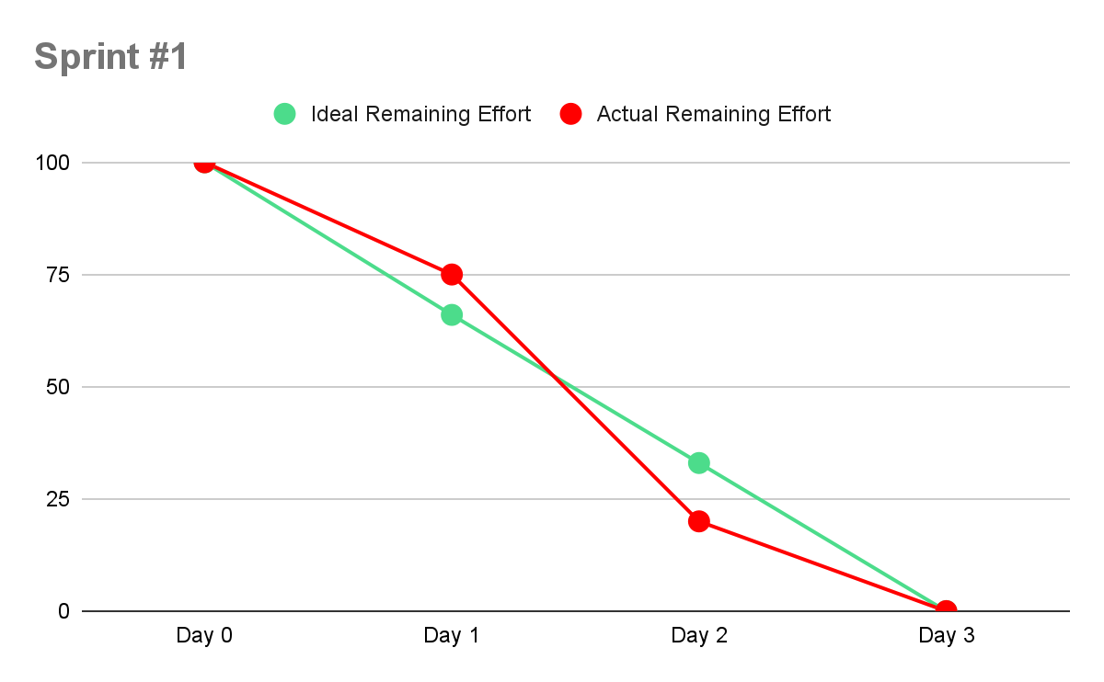

-we spent the first day designing the class diagram all 4 of us. That was time consuming, then we split up and worked more efficiently

